

Jenkins Auto upgrades of Solution Test Bench installers

Contents

Overview 2

Environment Setup 2

Jenkins Master-Slave 2

Creating a Slave node 3

Bringing up a slave 4

Associate Nodes to a Job 7

Creating a Parameterized Job 8

Executing the Parameterized Job 11

# Overview

This document is a user guide containing details of how STB Auto upgrade was achieved via Jenkins for the Solution Test Bench environment setup at Mphasis Bangalore. This setup even works fine on a clean install of STB provided the SQL server is already installed on the system.

# Environment Setup

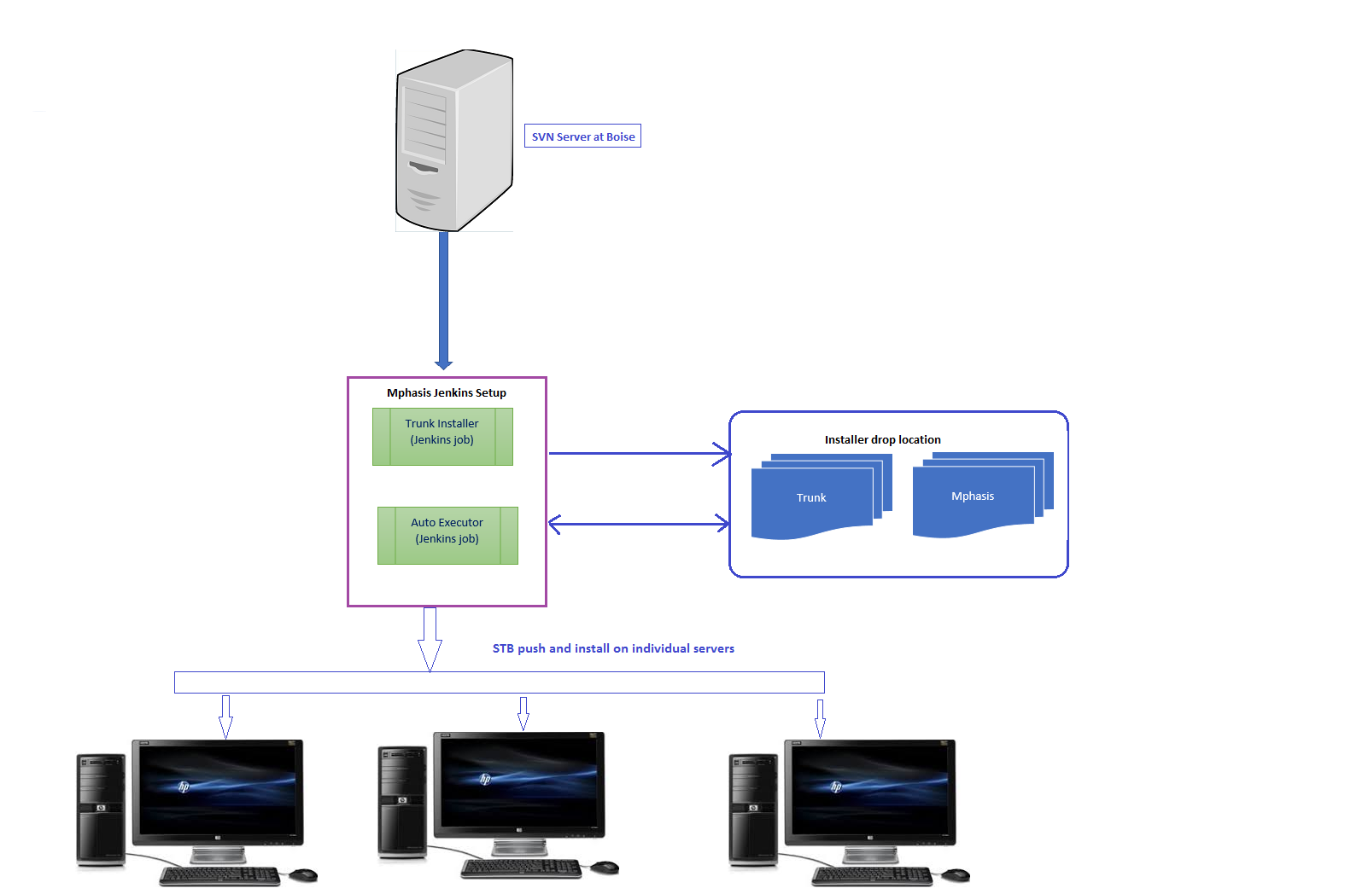

The above image shows an overview of the Jenkins environment Setup at Mphasis

# Jenkins Master-Slave

In our case master nodes are specific to Installer creations and copying the installer to a drop off location. Slaves are created to run the installers on individual systems which were created by the master. A slave node could be any host such as a lab server, laptop or a desktop on the HP network on which an activity needs to be performed. In our setup the master and slave have no relationship of any sort and they run separately.

Slaves nodes (user systems) need not have Jenkins installed in-order to perform an activity.

# Creating a Slave node

1. Click on **Manage Jenkins** and **Manage Nodes** in the list view

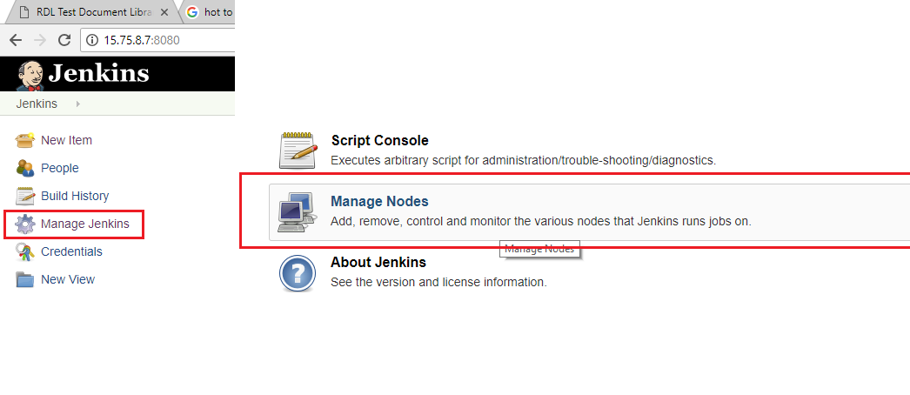

1. Create a New Node as shown below

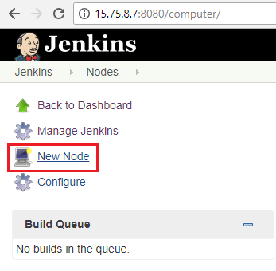

1. Specify a node name and select the node type

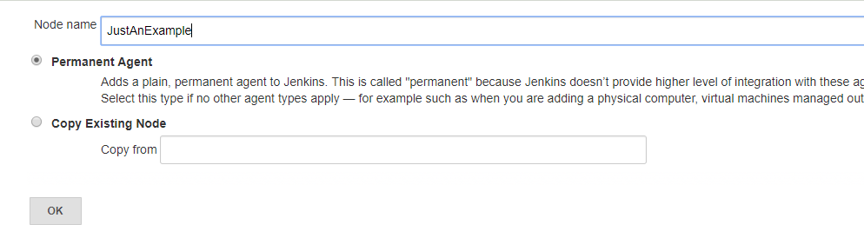

1. Fill out the form and hit on Save

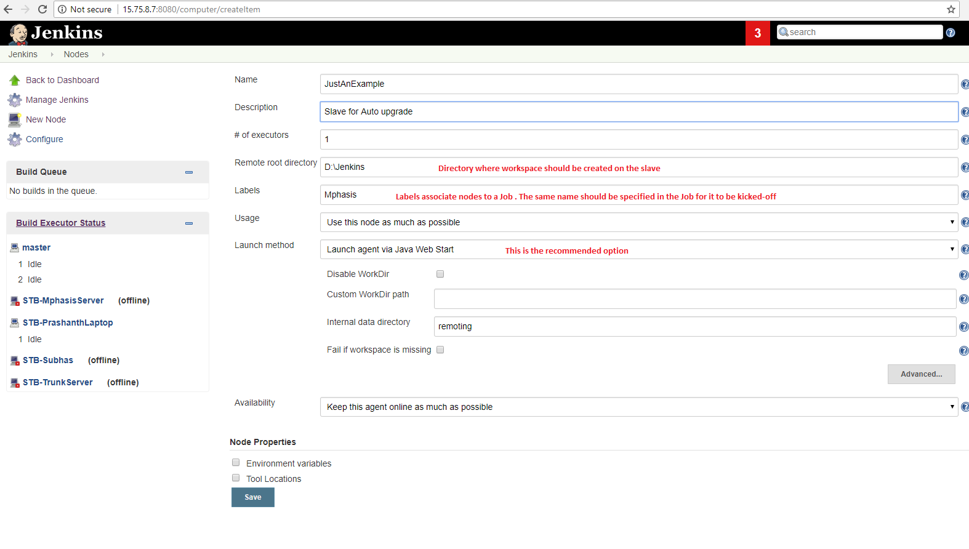

# Bringing up a slave

1. Login into remote system which you want to make it a slave
2. Open the URL in the web browser of the Jenkins server
3. On the Jenkins home page, click on the node you just created

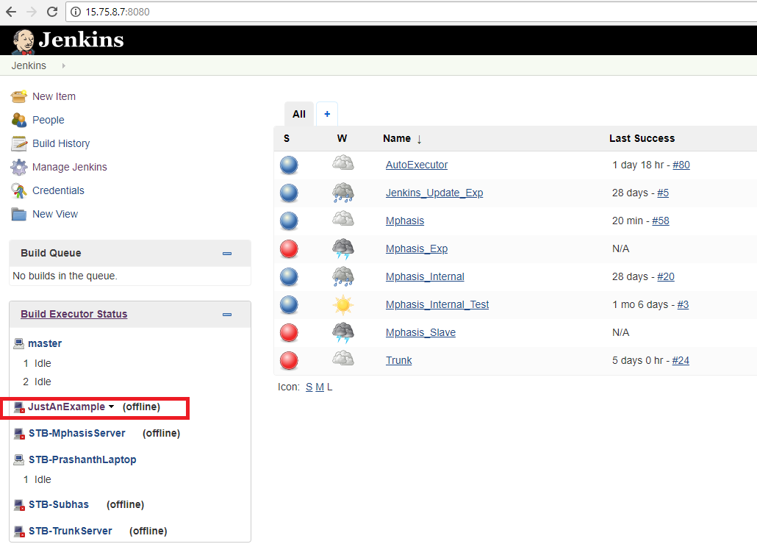

1. The following screen should show up with the following 3 options to bring up the slave

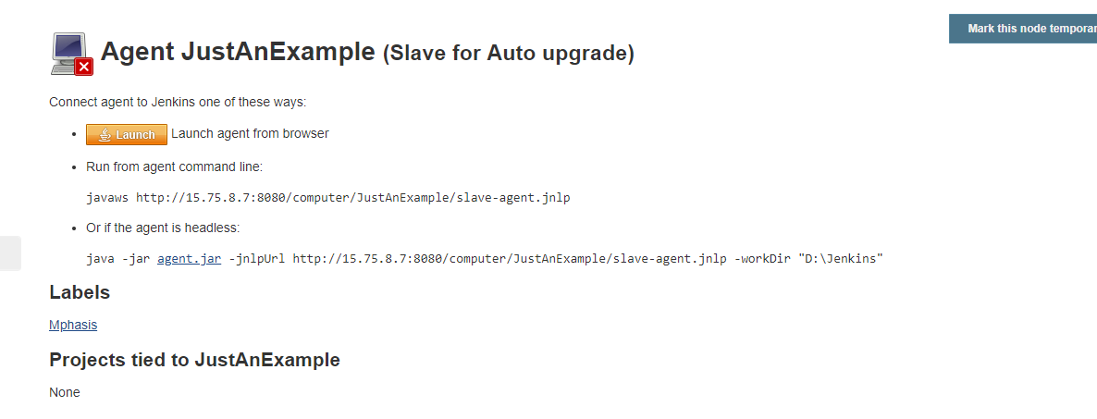

1. There are 3 ways the Slave can be made online. You can choose an appropriate method and connect. Click on Launch button and you should see a prompt telling about a download in the browser as shown below in chrome

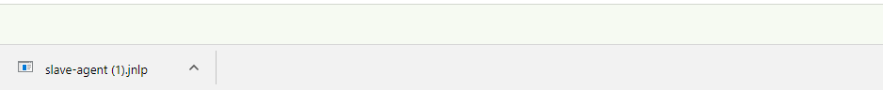

1. Open command prompt with Administrator rights and execute the slave-agent.jnlp . The same file can be found in the Downloads folder of windows
2. You must see this prompt

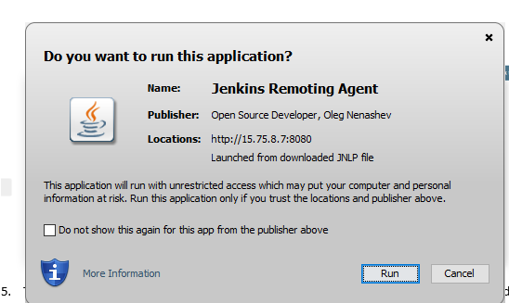

1. Once the connection is complete you must see this.

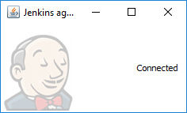

1. On a successful connect the slave should show an Idle status

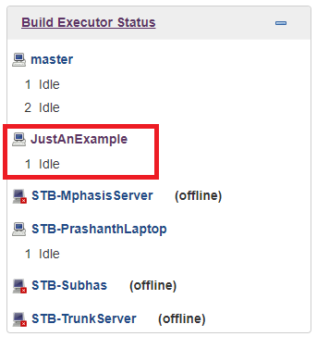

# Running Jenkins slave as Windows service

There is an alternative to connecting the slave node to the Jenkins server other than the using the web browser. Once the node is successfully connected, the slave node can be configured to run the slave as a windows service . This way the slave will automatically connect itself to the Jenkins server and will stay connected until widows is running .

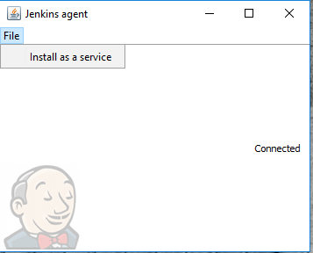

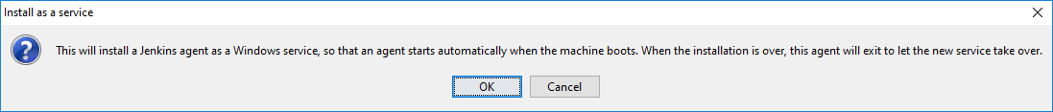

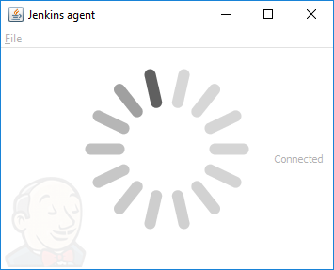

# Associate Nodes to a Job

Node can be associated with a job by specifying the same Label name in both node and job. Many nodes can be associated with one job and one node can be associated with many jobs. In the job we can restrict the nodes on which we need to perform actions on Slave nodes with a specific Label specified in the Job Configuration.

# Creating a Parameterized Job

A parameterized job can be linked to the nodes on which an action should be performed.

Apart from that, a parameterized job can accept inputs before the execution starts and the passed parameter can be used at run time as an $ENV variable to know what kind of action needs to be performed. This type of selection can be provided by specifying the **Choice Parameter** in the Job configuration. Also supported is string parameters which accepts values from the user for further filtration

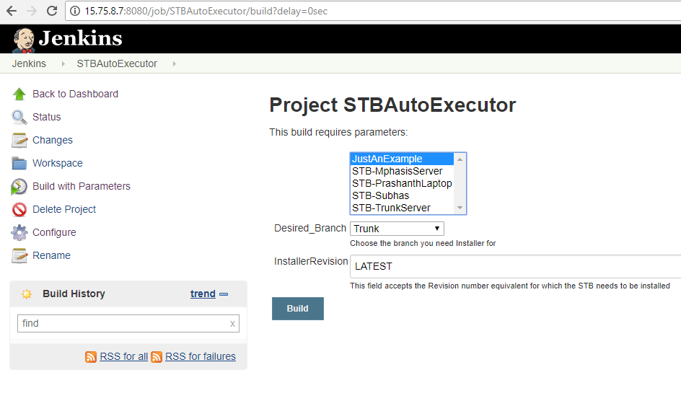

Fig (2.2) Parameterized job accepting Branch and desired revision

Below we are creating a Parameterized job which copies the STB installer from the specified location and saves it on a slave node. The tester/developer has the choice of choosing the branch from which he desires to be used. The user can also specify the revision number of a particular installer.

1. Click on Jenkins home page, click on **New Item**
2. Enter a Project name and select a Free Style project
3. Parameterize the project by selecting the checkbox as below

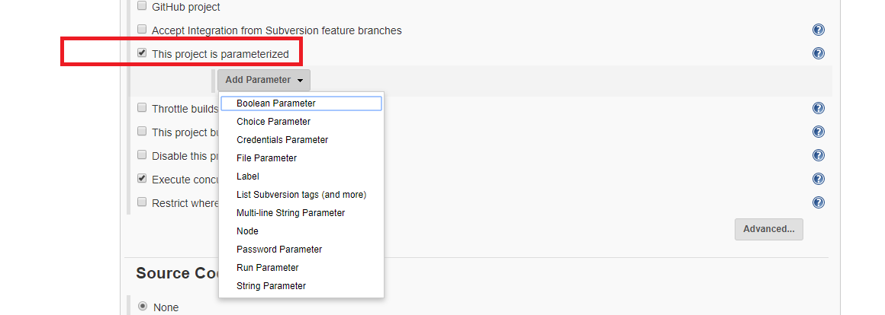

1. Next add a Node Parameter to specify your slave nodes. **Possible nodes** specify the nodes that needs to be considered for the Job. **Default nodes** specify the selections as shown in Fig 2.2 above. Check the radio ‘**Allow multi node selection for concurrent builds**’ if multiple nodes can be selected before a build kick off otherwise the list box is replaced with a dropdown in fig 2.2 .

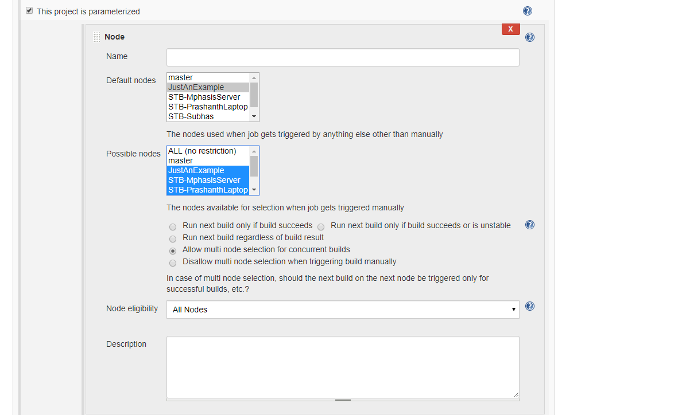

1. Specify choice parameter and String Parameter if needed as below

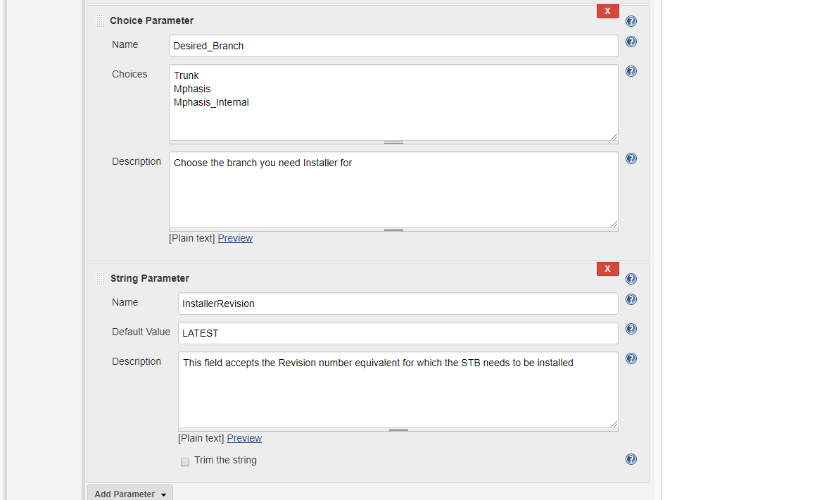

1. For concurrent build execution and restriction on labels set the below fields

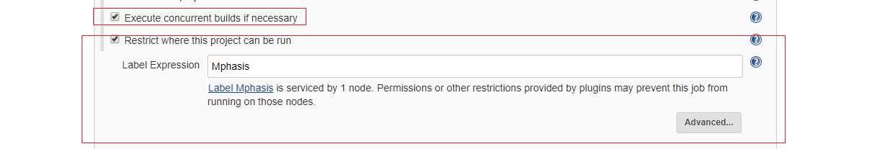

1. Add your build scripts that needs to be run on the Slave node. In our case we are copying the Installer from the Installer drop location and saving it in the Slave workspace.

After which the command to be run on the slave node for the silent installation of STB is specified.

e.g STBServer-AllPlugins-1.427.1115.26157_20180427 /VERYSILENT /SUPPRESSMSGBOXES /NORESTART

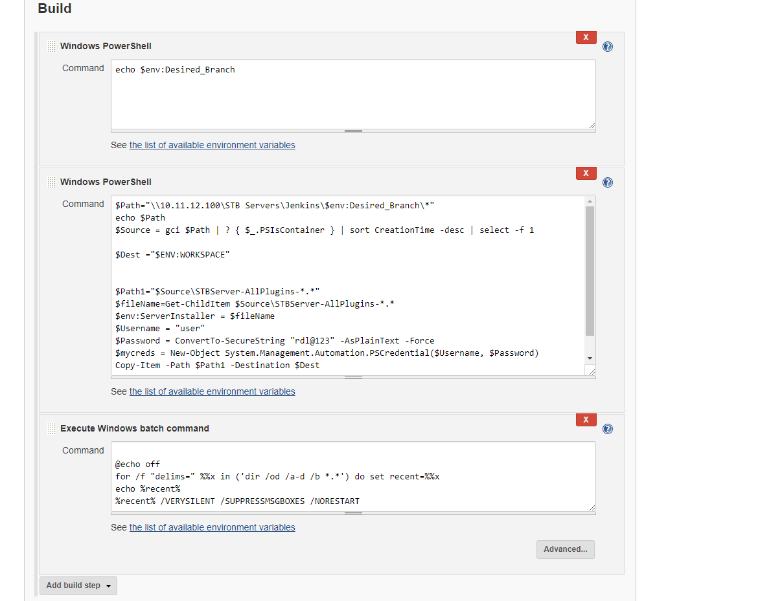

# Executing the Parameterized Job

On the Jenkins home page click on the Job to be executed. Select the slave nodes where the job needs to be performed and click build .

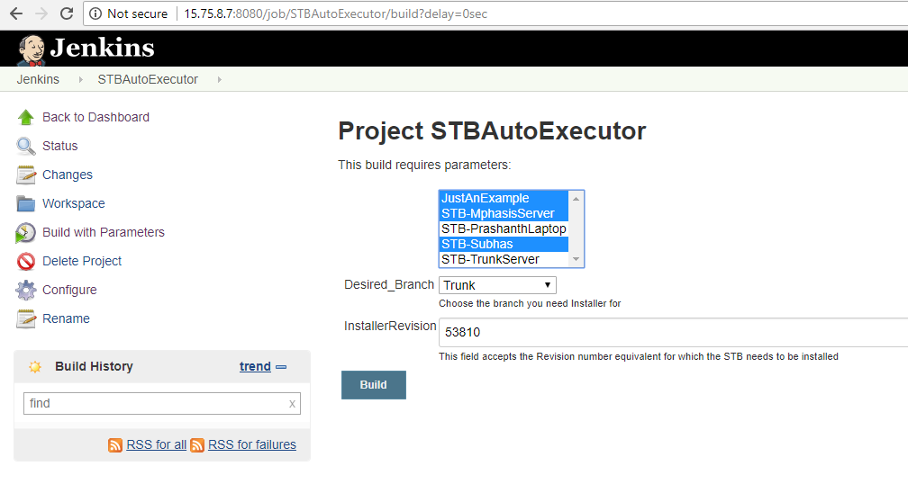

Once executed the builds are executed concurrently on the Slaves

